Cotton Disease Prediction

Vineet Kumar, Gla University, 201599031

Pawan Singh, Gla University, 201599017

Shreya Gupta, Gla University, 191500783

CSE-G95

**Abstract: -** Cotton is one of Ethiopia's Economically important agricultural products, but they are limited differently in terms of leaf area. These restrictions are often identified as pests and diseases that are difficult to see with the naked eye. "The purpose of this study was to develop a model to aid in the detection of cotton leaf diseases and insect pests using CNN's deep learning technology. To this end, researchers used common leaf diseases and insect pests such as bacterial wilt, spider mites, and leaf miners K A folded cross-validation strategy was used to split the data set and help generalize the model CNN  
  
Approximately 2400 samples (600 images classroom per sample) were used for educational purposes in this study was implemented using Python 3.7.3 version, and the model has a deep learning package called Keras supported by TensorFlow and Jupyter installed as a development environment. This model achieved an accuracy of 96.4% to classify leaf disease and cotton pests. He demonstrated the potential for use in real-time applications and the potential need for an IT solution to support the traditional or manual identification of diseases and pests

1. **Introduction: -**

Agriculture has played an important role in the financial development of most agricultural countries including India.  
Cotton rope is mainly found in northern India. In the past few years, cotton productivity has been adversely affected by various diseases. The most important requirements are acceptance of infection and planning. Plant diseases require careful diagnosis and prompt treatment to protect plants from serious losses.[1]

Farmers are notorious for over-diagnosing diseases, which makes control difficult and costly. The main reason for this is that farmers do not have access to experts, because it is difficult to train a large number of professional experts in China, so the rise of computer expert programs is a boon for farmers. These images are transmitted to a central expert information system on the disease and its treatment, accessible to farmers. Thus, human experts will provide diagnostic techniques to farmers. Computer scientists will use this information to create a training set for use in images to ensure that a disproportionate amount of disease can be detected. A pattern-matching algorithm will be developed for high-speed early detection of disease with acceptable accuracy. Cotton leaf disease diagnosis is the process of diagnosing diseases by analyzing their physical characteristics. The process of removing visible structures from the images is called feature extraction. Various feature descriptors can be used to perform the feature extraction process. Then pass the function descriptor as a delimiter to test the function. The separator is an algorithm used to rank items based on their similarity to the training database. A learned database is a set of features previously excluded from known objects. Diseased leaves were ranked based on their similarity to a previously described training database of disease patterns.  
  
Our goal is to resolve cotton infection using automated input image processing techniques. Diagnosis of the disease is highly dependent on the presence or absence of disease on the leaves of the cotton plant, which can be diagnosed using a separator. Field crops have issues like identifying plant nutrient deficiencies, identifying various pests and diseases that affect crops, and more. Everything has its own meaning. One of the problems is to detect pests so that appropriate measures can be taken to control them and thus reduce losses. In this case, the farmers know the pest and then they can take the appropriate measures to control the situation, but if the farmer does not have the correct information, there will be cases of misidentification of any pest and poor control will not help. exposure to pesticides. Use the results for hard work and wasted money. In addition, it can cause serious problems for plants.[2]  
  
Classification using the combined method has many limitations in calculating the number of sets available. Use a feature recognition system that uses paper recognition algorithms. The identification of plant leaves is done using a convolutional neural network. To refine and integrate these features into CNN, these features are extracted and processed by PCA. A new image recognition method based on wavelet transform and singular value decomposition allows the extraction of multiple images such as the target image.[3] When using a wavelet image for the top back, better edge detail can be obtained with wavelet properties such as strength and entropy by extracting the improved edge detail and using it through additional rotation. Wavelet functions and methods are incorporated into the system to provide more accurate results. It also uses PCA analysis to reduce the time required for processing by reducing factors. Increasingly, these diseases are classified using deconvolutional neural networks. This method reduces processing time and improves accuracy.

**2.Statement Of the problem:**

Cotton is susceptible to multiple disturbances (biological and abiotic limitations) due to temperature fluctuations, diseases, and pests. In fact, around 600 kg of cotton per hectare was produced worldwide, of which only 10% of production losses were due to various cotton leaf diseases. The United States (USA) is the world's largest exporter of cotton, receiving $5.1 billion in 2016, but there are well-known local pests wreaking havoc on cotton farms. And India has 24% of the world's cotton plantations and has gained 4%.  
In 2016, it was $6 billion, of which a total of 18% of the cotton crop was lost each year due to various diseases affecting cotton, resulting in a loss of nearly 900,000 Indian rupees. Currently, about 12-15% of the cotton crops in Ethiopia are infected with various diseases.  
Efficiency evaluation of GTR-I in Ethiopia showed that these diseases and pests are major constraints on world standards for cotton quality and cotton yield.  
leads to economic collapse for both farmers and the country. Detecting these diseases with the naked eye made it difficult to judge cotton productivity, resulting in poor identification accuracy. Even experts cannot evaluate and diagnose [4]. the disease with the naked eye, and this inadequate technique results in much higher cotton yields. These erroneous conclusions lead in most cases to the use of certain unnecessary pesticides that are not good for healthy cotton. Leaving a farm without production, even for a short period of time, will affect the country's overall GDP.  
  
Researchers submitted the following research questions based on the issues identified in the problem statements.  
  
(1) Which method is suitable for diagnosing cotton diseases and pests?  
(2) How to develop an automatic cotton disease diagnosis system and pest diagnosis system?  
(3) How to determine model acquisition?  
  
Deep learning includes image processing and data analysis as pathways to more results. Since it application was accepted and I am now entering the agricultural field. Today, various deep learning-based computers for vision applications can perform the task precisely. Do. However, the most important application of this research is CNN. Today, CNN technology is used to detect different objects and execute automatic drawing instructions for analysis. Recently, the K-fold cross-validation strategy has recently been recommended for dataset partitioning and has facilitated the generalization of CNN models. Typically, leading-edge models are developed from scratch rather than any other transfer learning or engagement model. Deep learning focuses on optimizing classification performance in different tasks, which helps inform human intervention data. In this real context, the use of deep learning has shown great interest in decoding human brain activity. Inter-assay and within-subject variability of EEG signals for attention-based bidirectional long-term local memory access. Convolutional neural networks have been classified into four types of EEG motor imaging functions under different analysis factors. Here, different features are extracted from raw EEG signals using a bidirectional model of long-term memory and attention. The system supports paralyzed patients, promotes the clinical transformation of brain-computer interface technology based on EEG motor imagery, and meets various needs. Exceptional performance includes maximum accuracy and time-resolved predictions. People contributed to the creation of effective and efficient interface systems. Due to the similarity of EEG electrodes, a new deep learning framework, Convolutional Neural Network Graph, solves this problem by combining and distinguishing four categories of motor imagery intentions. To identify motor imagery, the four tasks with the highest predictive accuracy were selected.[5]

**3. Research Scope and Limitations: -**

The purpose of this study was to develop a cotton leaf rust recognition model using a deep learning technique known as convolutional neural networks. Three common pests and diseases, fire blight, leaf miner, and red spider mite, affect cotton yield and quality. The applied model also uses supervised learning techniques on the 2400 datasets, with four main feature extraction processes. This dataset is limited to four different entity descriptions. Due to the limitation of time and area of ​​cotton production, this study mainly focuses on southern Ethiopia

The MelkaWorer Centre for Agricultural Research has been proposed as a priority area as it is responsible for cotton farming in SNPR. We performed automatic feature removals on different input datasets using deep-learning methods

**4. Literature: -**

According to reports, they mapped different convolutional neural networks on the graph mat. For communication with EEG electrodes, it is prepared to process integrated EEG data to predict four classes of virtual movement. They accessed their data with a 2D to 3D perspective transformation. Structures were processed using these units. The study showed that the short-term voltage stability of the was suggested for use with the dynamic deep learning path.[6]

They modified the clustering algorithm for short-term voltage stability to improve reliability. A deep learning method for detecting various mango leaf diseases is described. The researchers studied nearly 1,200 data sets using five different leaf diseases in different mango leaf samples. The ACNN framework is trained using over 600 images, 80% of which are used for training and 20% for testing. The remaining 600 images are used to assess the accuracy and detection of mango leaf disease and demonstrate its potential for real-time applications.  
  
If more images are provided to the dataset by adjusting the CNN model parameters, the classification accuracy can be further improved. This study describes the use of a rice plant dataset recognition and classification engine to process a CNN model. For training, about 500 images of different diseases were collected for processing in experimental rice fields. The problem of detecting cotton sheets is solved by image processing. Here the K-means algorithm is used to divide the dataset into parts.  
  
Studies have shown that this disease has been found in banana plants affecting the leaves. This study used 2400 images for training, but there is no balanced dataset for each class, so the training mode uses a color dataset and grayscale images and defines the data. They achieved the best accuracy: 98.8% on color images, 80% on training, and 20% on the validation dataset.[7]

ResNet-50 Algorithm Implementation Steps

Step 1: Obtain Required Libraries: Perhaps the most important step is to import the libraries needed for image classification.

Step 2: Download and extract the following files: The next step is to open

Google Collab and download the dataset file. It will then be saved in your Collab file repository, where we will be able to create a port to the image or dataset that we require. The next step is to use the command and the full file name to extract the document.

Step 3: ResNet-50 photo pre-processing: Load the photos from the dataset before beginning the pre-processing process. When loading images, try changing the target size to 224*224 for Res Net.

Step 4: Make the following estimate in Keras using ResNet-50 model: We can begin categorizing the picture after pre-processing it by simply incorporating the ResNet-50 model

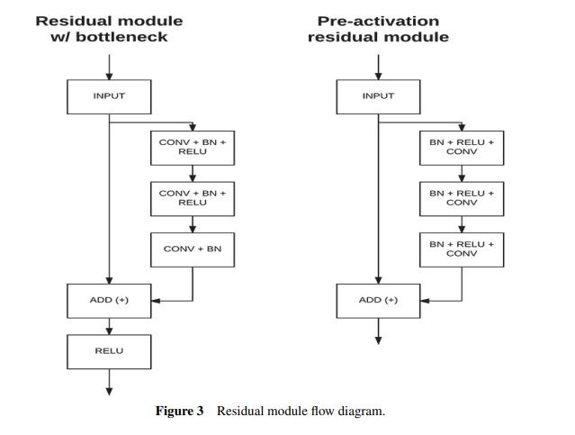

Resnet Implementation

Using Tensor-flow and the Keras API, we can construct a ResNet architecture (including remaining blocks) and learn the fate of in the process. Figure 5 depicts the ResNet architecture as a flowchart. This implementation makes use of the CIFAR-10 dataset. This dataset includes 60,000 32-bit colour photographs of planes, cars, birds, cats, deer, dogs, frogs, ponies, boats, and trucks, among other things. These datasets can be evaluated using Keras Database API functions. To begin, import the Keras component and its API. (Application Programming Interface). These APIs (Application Programming Interfaces) make it simple to create the ResNet mod's structure.[6]

Layers of Convolution: Convolution is the fundamental process of applying filters to input to generate enabled layers. When the same filter is applied to an input repeatedly, a feature vector representing the location and intensity of the features identified in the input emerges, similar to an image. Convolutional neural networks are unique in their ability to train a large number of pixels in parallel, particularly when using test data within the constraints of a given predictive modeling problem, such as image classification. As a result, the input photo contains extremely sharp features.

**5. Research Methods: -**

This research uses design science to create and evaluate methods, using qualitative or quantitative data to create innovations and define ideas, methods, technical capabilities, and products. One of the outputs of DSRM is the model. Conceptual representation and abstraction of datasets. that of Hefner. The figure shows the treatment model for this study. Among the various entry points, "problem introduction" is the most appropriate for the design of scientific research. Capsule Tracking researchers and companies monitor this problem and therefore apply a problem-focused entry point. The figure shows the DSRM proposed in the study and the activities applied.[1]

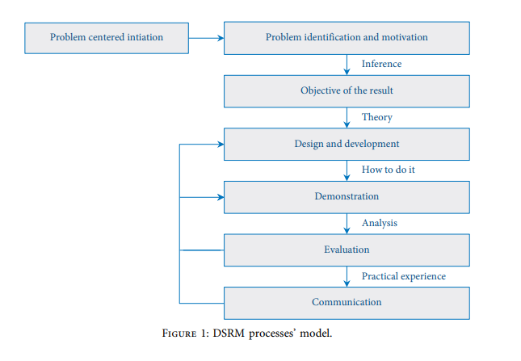

DATA COLLECTION AND SAMPLING TECHNIQUES: - The example leaf and tree images used by the researchers are the main types of data sets. Raw data is fresh data collected for the first time. The main types were collected from Arba Minch, Shele, and Woyto cotton farms where SNNPR cotton is widely grown, and each cotton plant collected in Malacca from July 2019 to August 2019 had a high infection rate. . . It is obtained from the secondary data category. Creation of labor agronomy research centers in extreme regions and SNNPR.[9]  
  
In this study, the researchers used purposive or judgmental sampling techniques and selected three infected samples and one healthy sample from the population, which is unlikely. During the data collection process, 2400 databases were collected, which were divided into four categories: bacteria, health, leaf miners, and red spider wilt. They are used for training. Balanced Dataset  
1. Surface Image Digitization Samples: - Data Acquisition System This study acquires clear, unbiased, and simplified digital images of leaves from the database. Store cotton mill data for later analysis and processing. The goal is to provide uniform or balanced lighting for digital systems. Images taken with smartphone cameras and digital cameras are transferred to a computer where they are displayed on the screen as digital color images in PNG format and stored on the hard drive.  
  
2. Pre-processing image data: - In any image processing project, the web is the first step. Vectorization, normalization, image transformation, and image scaling are all common image pre-processing tasks in image-processing projects. These image pre-processing tasks were carried out in this study before the subsequent deep-learning processing using the Python OpenCV library. Data augmentation is also used to generate additional training datasets from real datasets from which to sample data.

3. Feature Extraction: Deep learning employs the best and most powerful CNN method to overcome the limitations of machine learning feature extraction, such as manual feature extraction. Knowledge is explored using hierarchies. It matches and extracts these values with data using a filtering mechanism.  
  
4. Method for splitting datasets and selecting models: -K-fold cross-validation is used to split the dataset, which splits K values, of which K+1 is used for the next division. In this study, the researchers used the K value of 10 recommended by deep learning [8, 20]. K=10 denotes ten cross-validations, and the dataset is divisible by ten. Each time, D=2400/10=240 data is used. 80% (2160 leaf images) of these regular campaigns produced the best results, while the remaining 20% (240 leaf images) were used for testing. As a result, the system has been validated.  
5. Tool selection: **-** For this study, two imaging devices, a smartphone, and a digital camera were used to collect images of cotton. To use the proposed model, Python version 3.7.3 is required. The model was also trained in Keras, version 2.2, which includes support for TensorFlow 4-tf. TensorFlow, version 1.14.0, is used in the recommender system. Some tweaks to test performance with the Tkinter GUI. Training and testing are performed on the CPU rather than the GPU in terms of hardware.[1]

6. Methods of evaluation: -Researchers use various methods to assess the structure's regularity at various stages, such as the development and closure phases. The researchers began by assessing prototype acquisition using a confusion matrix and the four scores reported by the confusion matrix: F1 score, precision, recall, and precision on the test data set.

Second, in this study, researchers used questionnaires to assess the archetypal performance of subject matter experts for subjective assessment. The objective evaluation process entails empirically testing artifacts. Finally, the evaluation results demonstrate the model's practical applicability.

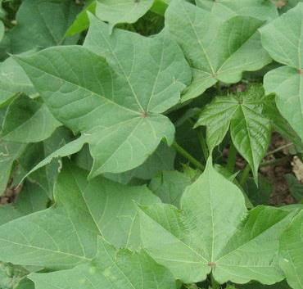

Image: - Healthy Leaf

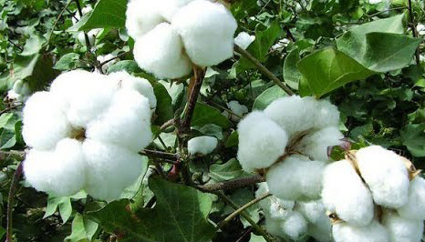

Image: - Healthy Tree

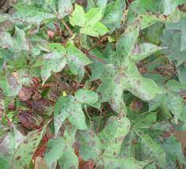

Image: - Un- Healthy Leaf

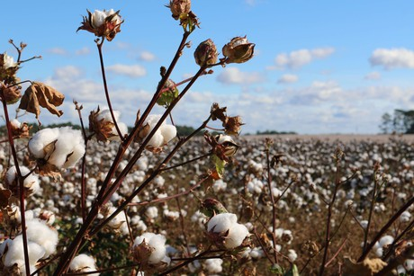

Image: - Un -Healthy Tree

7. Modelling Cotton Pest Identification: - Model development tasks include gathering images in the field with digital cameras and smartphones. Following that, image pre-processing techniques are used to prepare the resulting images for further analysis. The pre-processed image is then fed into a CNN algorithm, which uses a neural network for feature extraction. The image slices that best represent the image are then extracted using image analysis methods. Training and test data are extracted and used for recognition based on the extracted features. Finally, as shown in Figure, the trained knowledge base categorizes new images based on symptom categories.[10]

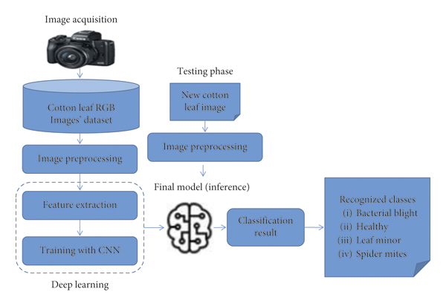  
  
8. CNN Architecture Model: Ends at the output layer. As shown, the hidden layer consists of several layers. 6. Here we have cotton leaves, the output will be the class names of these images, also known as cotton leaf disease or pest labels. In general, for this proposed architecture, each added neural image is infused with salience weights. The output of the scaling process in the next layer is processed and repeated in the next layer. The output layer shows the prediction tasks of the computational neurons in this study.

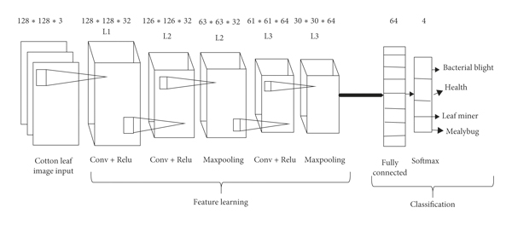

9. Deep Convolutional Neural Network Training:

To model the separation of images from a dataset, it is proposed to train a deep convolutional neural network. Python Theano Library and Torch7 Lua Extended Electronics Library are comprehensive learning frameworks. Caffe, a comprehensive source code learning framework developed by BVLC, including the CaffeNet reference model, is also available. CaffeNet is a multilayered deep CNN that integrates the functionality of real-time input images. There are eight playback levels, and five canonical update levels fully integrated into the network. CaffeNet is still in its infancy updated to 15 industries.

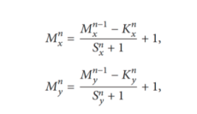The CL serves as the foundation for constructing a CNN. Each CL is made up of equal-sized maps, Mx and Kx is the size located to a specific image, and Ky. The Sx and SY sketch elements specify how many pixels on the x and y axes are skipped by the filter kernel between subsequent interactions. The output map's size can be specified as follows:

where n denotes the layer. Each map in Ln is linked to the majority of Mn-1 maps in Ln-1. Rectified Linear Units (ReLU) are exactly what their name implies.

Deep CNNs with ReLU train more quickly. The set of convolutional and fully connected layers is extracted using this technique. Except for exit, no standard fit is required; after ReLU decoupling the first and second convolutional layers as it reduces top-1 and top-5 values. CNNs categorize neurons in a latent layer as "feature maps." Each neuron in the feature map has the same weights and biases. The neurons search for the same feature in the cartographic elements. These neurons differ from others because they are linked to neurons in the underlying layer. As a result, the neurons in the feature map will be linked to different regions of the first masked layer containing the input image. The feature map divides the hidden layer into parts, with each neuron looking. Feature maps are created by applying convolutions to the entire image. Starting with the CL, which displays elements ranging from single pixels to simple lines, and ending with the CL which displays hierarchical features and partial leaves, represents the best performance Pooling increases translation flexibility by operating independently of the input depth chip and scaling it geographically. To use an over-over-reduction, over-mixing is used. To reduce overfeeding, a top coat is applied to the first two fully bonded layers. If it does not give up, the training time increases by n times when read by to a regular neural network built directly.

According to the Bazesian performance test, ReLU and Leavers have a synergistic effect, which means they work better together. CNNs' progress is determined by They look into the possibility of using intermediate image representations with conflicting and low-level features for alternative image classification methods.

10. Testing:

To assess the task of ANN in which data is divided into training and test sets, the NN is updated on the corresponding sets, and the neural network is trained on the prediction test set. As a result, the outcome model is known, and we can calculate the prediction's accuracy. A separate experiment was carried out using the original image database and larger images.

The database has been conditioned.

To test the predictive model's accuracy, use a 10-fold cross-validation procedure. Repeat the cross-validation process every 1000 training epochs. The total measurement result of the test is denoted symbolically by top-1. (Most likely) is the same as the target label, and whether the higher category is better is determined. The top 5 error level is used to determine whether it is on up or not Section 4 displays the entire database as well as individual test results for each category.

11. Adjustment:

Make small adjustments to improve or maximise the efficiency of a process or function. In the original Caffe Net model, the partition function is a SoftMax classifier that combines images from multiple classes in the ImageNet dataset. Preparing for the exam takes just as much study, but it's much faster than starting from scratch. Delete this SoftMax scanner to start the fine-tuning process and set a new separator with random values. To change the hidden layers and hyperparameters, repeat the fine-tuning process. A limit test fitting process was used to find the best plant disease detection model.

12. Deploy:

The trained model is deployed using the jar file in this step. Flask is a lightweight Python-based web framework. It is divided into small tasks because it does not require any special tools or libraries. It lacks database abstraction layers, form validation, and other projects that rely on third-party libraries for similar functionality. Flask, allows you to add functionality to your app as if it were written in Flask.

**6. Deployment**

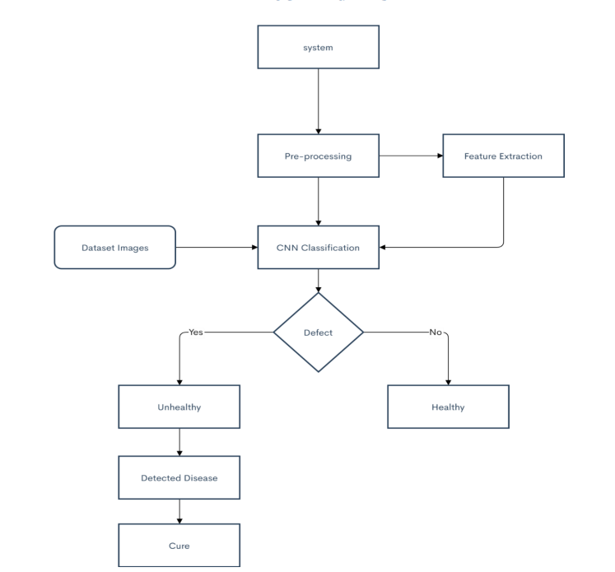

14. Experimental results: **-** During the experiments, several experiments were done for a valid model by adjusting various parameters and giving different results. These options are dataset color, number of epochs, scale, optimizer, and drop out. According to people, enhanced RGB images are approximately 15% more accurate than unenhanced images. For this new model, the researchers trained three different numbers of epochs: 50, 100, and 150. However, the model achieves the best performance over more than 100 channels, as shown in Figure. A person has a CNN loss (2.7%) with additional aspect performance, so researchers used 0.25 and 0.5% loss per layer in the experiments the best performance from 0 to 0.5 %. Finally, we perform a very important experiment on regularization methods, showing that optimization algorithms can reduce loss iterations by updating the mean according to gradients. The figure shows numbers on the loop and normalization methods. In this study, two recently used optimization algorithms are used, RMSProp and Adam, but Adam's optimization algorithm reduces the loss to 2.5%, as shown in Figure.

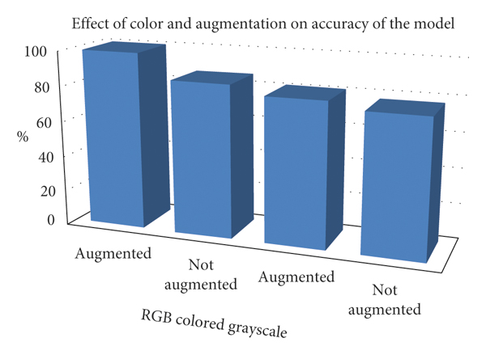

15. Discussion of the Findings: **-** The final outcome is obtained by analysing the model's performance using parameters such as K-fold cross-validation with 10 folds. On the RGB color image dataset, the model performs best when scaled by 15%. The accuracy rate on the grayscale dataset when using the transfer learning CNN model is 98.6%. However, because color important and decisive feature in detecting and classifying cotton, training a model with coloured data takes a long time, even with complex layers. Adam's optimization method and 100 iteration cycles improved model performance by 10% and 5.2%, respectively. Finally, the developed CNN model detected bacteria with 98% accuracy.

**7. Conclusion: -**

This deep learning framework is built with Python and Keras packages, with Jupyter as the development environment. In this study, several experiments were performed to obtain efficient models by adjusting various parameters such as dataset color, number of time periods, augmentation, and regularisation methods. When the RGB color image dataset is increased by 15%, the model performs best. Model performance is improved by 10% and 5.2%, respectively, by increasing the epochs and the regularisation method. The proposed prototype has a maximum efficiency of 96.4% against a variety of cotton plant foliar pests. These automated systems are being developed to assist farmers and experts in identifying cotton pests and diseases through visual leaf inspection.

**8. Future plans include:**

Collecting a large number of high-quality training images of various shapes, sizes, backgrounds, illumination intensities, and orientations is a significant challenge in the development of deep-learning object detection models. Future researchers should strive to incorporate solutions to these issues into their work, not just to identify diseases and pests, but also to propose treatments. Ethiopia launched the satellite in 2019, which was the best decision for future researchers looking to remotely access high-resolution satellite imagery to train high-performance.

**9. Reference: -**

1. "An Improved Cotton Disease Identification Method Based on Deep Learning", by J. Zhang, et al. (2021). This paper proposes an improved method for cotton disease recognition including transfer and attention learning mechanisms. The proposed model achieves high accuracy in identifying three common cotton diseases: bacterial rust, leaf roll virus, and fusarium wilt.
2. "Cotton Disease Recognition Using Convolutional Neural Networks with Transfer Learning" by S. Jain et al. (2021). This article presents a CNN-based approach using transfer learning techniques to identify four common cotton diseases: bacterial rust, Fusarium wilt, leaf roll virus, and Verticillium wilt. The proposed model achieves high accuracy and outperforms other machine learning techniques.
3. “Cotton Disease Classification Using a Hybrid Feature Extraction and Classification Algorithm” by N. Ali et al. (2020). This article presents a hybrid approach for cotton disease classification using deep learning and traditional machine learning techniques. The proposed model achieved high accuracy in classifying five common cotton diseases and outperformed other machine-learning techniques."
4. “Cotton Disease Detection Using Transfer Learning and Feature Extraction” by A. Bhatt et al. (2021). This paper presents a hybrid approach for cotton disease detection using transfer learning and feature extraction techniques. The proposed model achieved high accuracy in detecting four common cotton diseases and outperformed other machine-learning techniques.
5. "Cotton Disease Detection and Classification Using Convolutional Neural Networks" by M. E. Rahmani et al. (2019). This article proposes a based approach to detect and classify cotton diseases. The proposed model has high accuracy in detecting three common cotton diseases: bacterial rust, leaf roll virus, and fusarium wilt.
6. "Cotton Disease Detection Using Deep Convolutional Neural Networks" by M. S. Al-Ansari et al. (2018). This article proposes a CNN-based method to detect four types of cotton diseases: bacterial rust, fusarium, leaf roll virus, and verticillium wilt. The proposed model achieves high accuracy and outperforms other machine-learning techniques
7. "Cotton leaf disease detection and classification using convolutional neural networks", by P. R. Parikh . (2020). This article proposes a CNN-based method to detect and classify five common cotton leaf diseases. The proposed model achieves high accuracy in disease detection and classification and outperforms other machine-learning techniques.
8. “Cotton Disease Identification Using Deep Learning R. Ptel(2019). This article provides a CNN-based approach to identify four common cotton diseases: bacterial rust, Fusarium wilt, leaf roll virus, and Verticillium wilt. The proposed model achieves high accuracy and outperforms other machine learning techniques.